Sensor Based Robotics (ECE 5233)

Project Part 1 Report

Team Members:

Rajath Koratagere Manjunath (rkm350)

Rajat Ravindrakumar Bapuri (rrb398)

Sushanth Shabnavees (ss12376)

Part 1

1. **Write the direct kinematic equations in minimum parametrization.**

Following diagram illustrates the axes according to the DH conventions and the table gives the DH parameters.

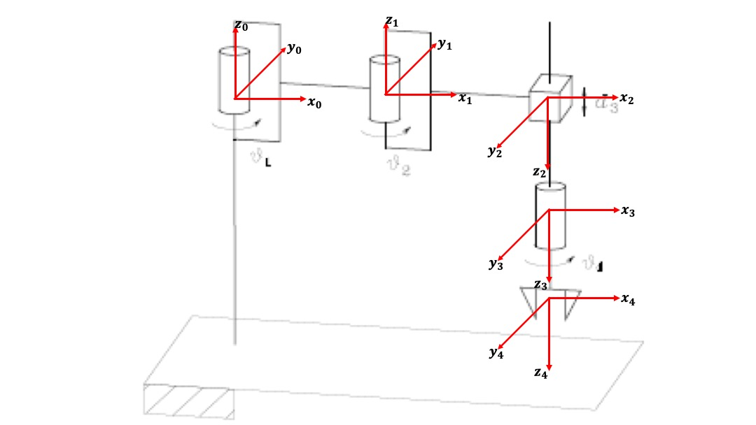

|  |  |  |  |  |
| --- | --- | --- | --- | --- |
| Link | $$a_{i}$$ | $$α_{i}$$ | $$d_{i}$$ | $$θ_{i}$$ |
| Link 1 | $$a_{1}$$ | 0 | 0 | $$θ_{1}$$ |
| Link 2 | $$a_{2}$$ | 180° | 0 | $$θ_{2}$$ |
| Link 3 | 0 | 0 | $$d_{3}$$ | 0 |
| Link 4 | 0 | 0 | 0 | $$θ_{4}$$ |

Direct kinematic equations are written as follows:

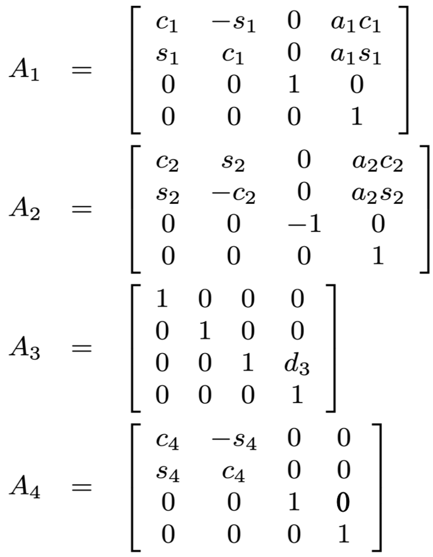

Final homogeneous equation is as follows:

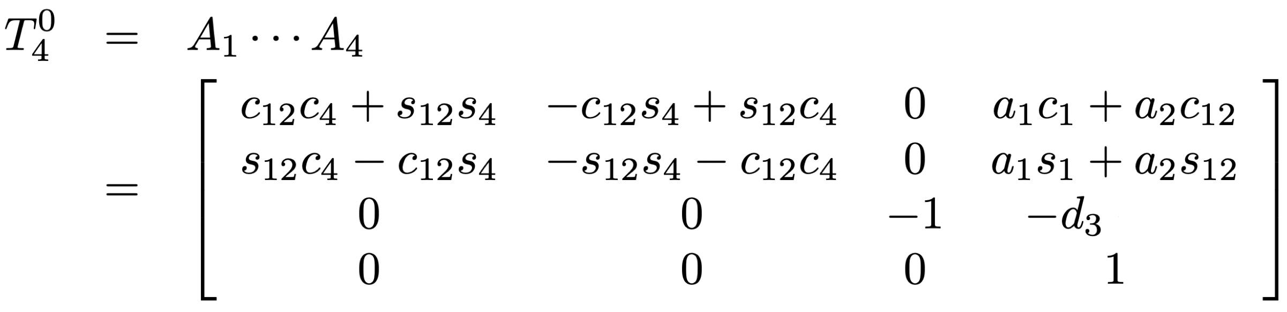

1. **Write the differential kinematic equations.**

Differential kinematic equations are as follows:

$$\begin{matrix}-a_{1}s_{1}-a_{2}s_{12} & -a_{2}s_{12} \\ a_{1}c_{1}+a_{2}c_{12} & a_{2}c_{12}\end{matrix} \begin{matrix}0 & 0 \\ 0 & 0\end{matrix}$$

$$\begin{matrix} 0 & 0 \\ 1 & 1\end{matrix} \begin{matrix} -1 & 0 \\ 0 & 1\end{matrix}$$

J =

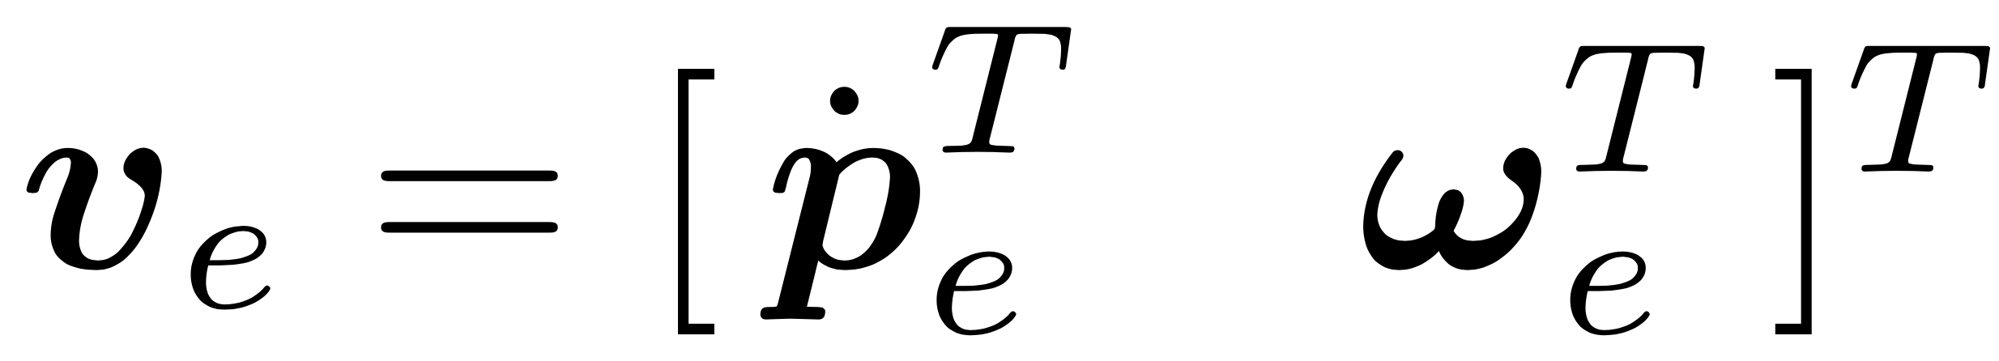

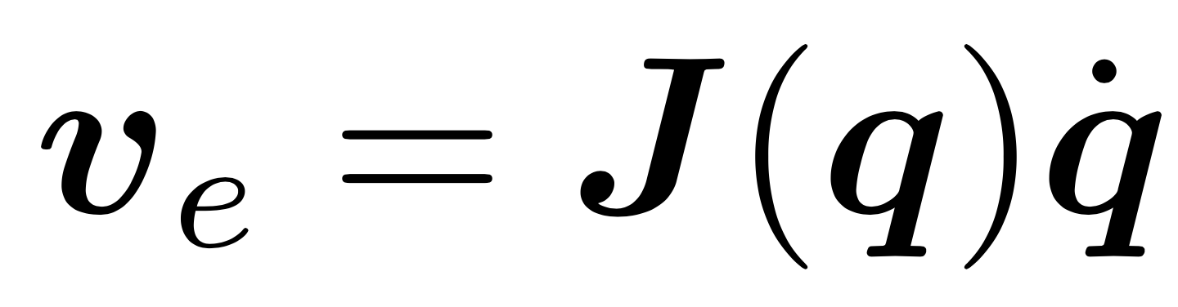

1. **Is the geometric Jacobian the same of the analytic one? Explain why.**

**The analytical jacobian and the geometric one is the same since the orientation part does not change and it is represented by a single angle.**

The angular velocity of the end-effector in end effector frame is along the z axis and is represented by a single angle. Hence the J_0 of the geometric jacobian and the phi_dot of the analytical jacobian are same. Hence the Analytical Jacobian and the Geometric Jacobian are same.

1. **Plot the joint variables and the errors in the operational space.**

**Jacobian Inverse:**

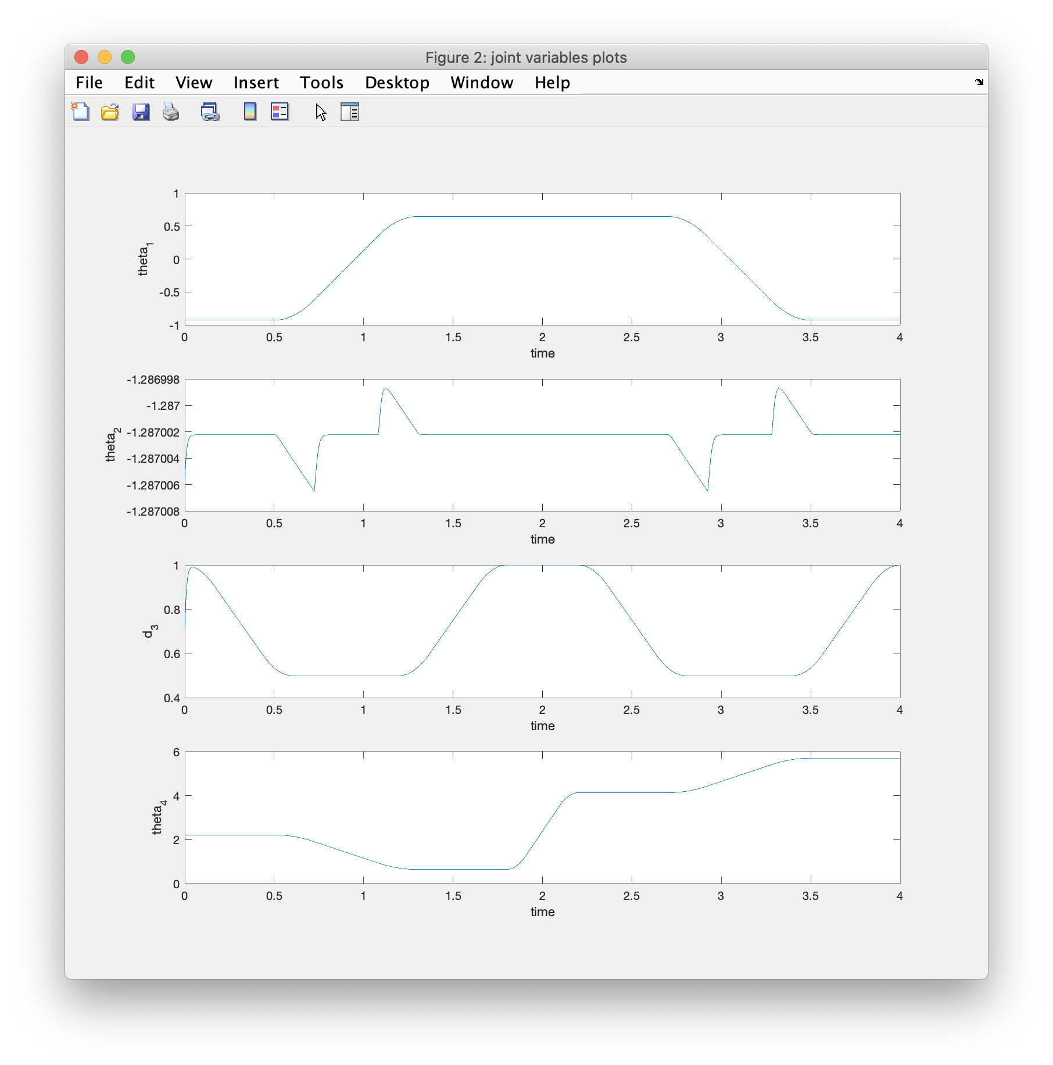

Joint Variables plot in the operational space:

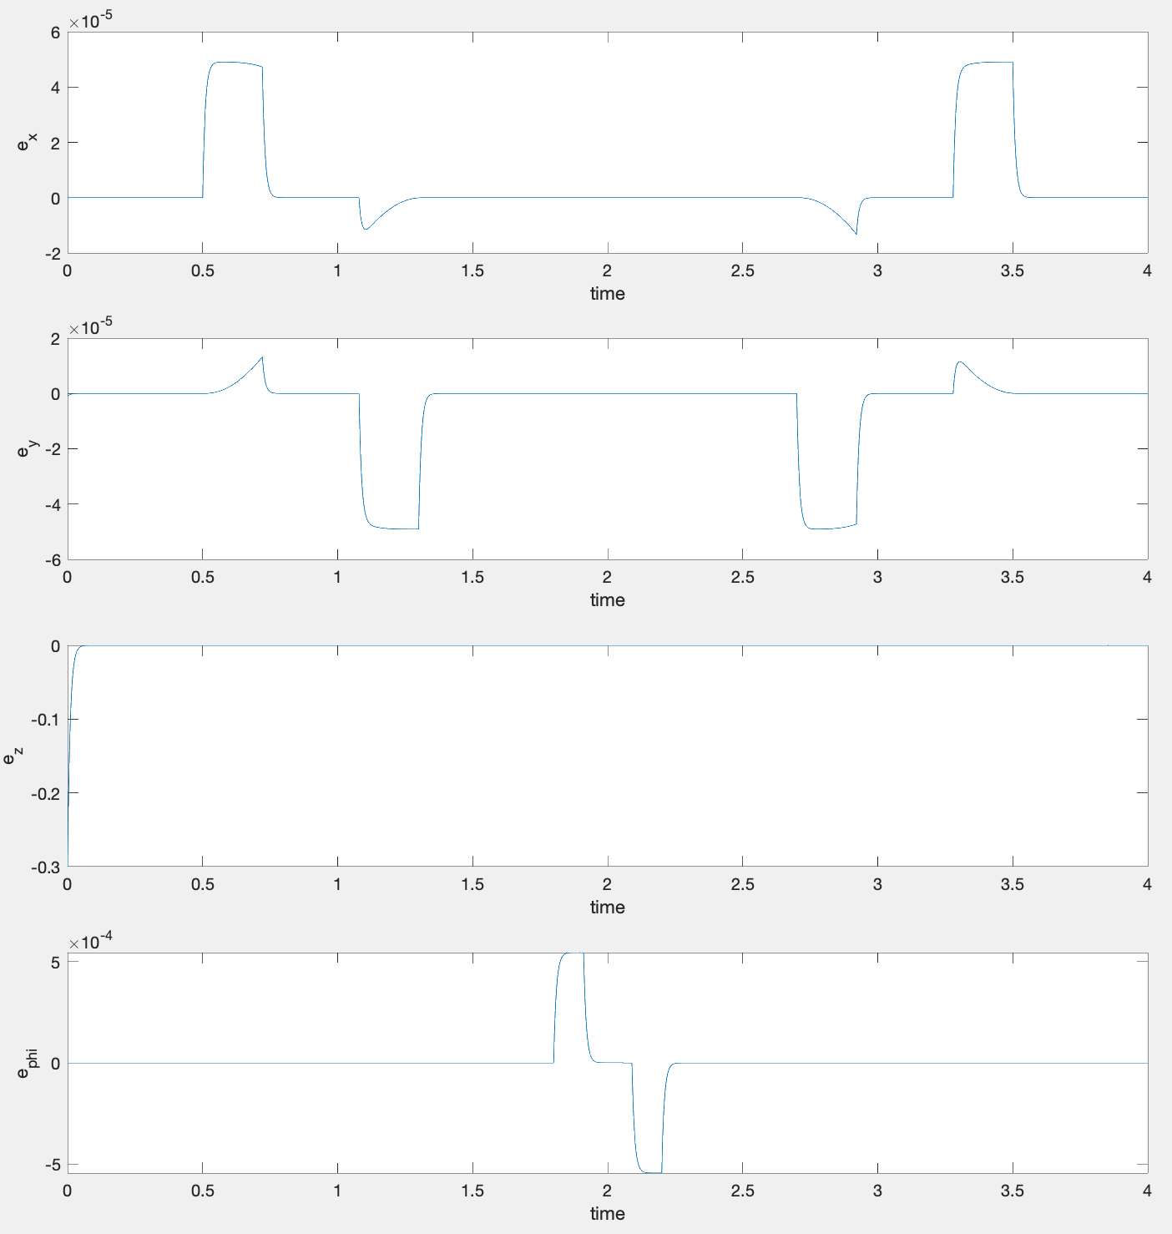

Error Variables plot in the operational space:

**Jacobian Transpose**

Joint Variables plot in the operational space:

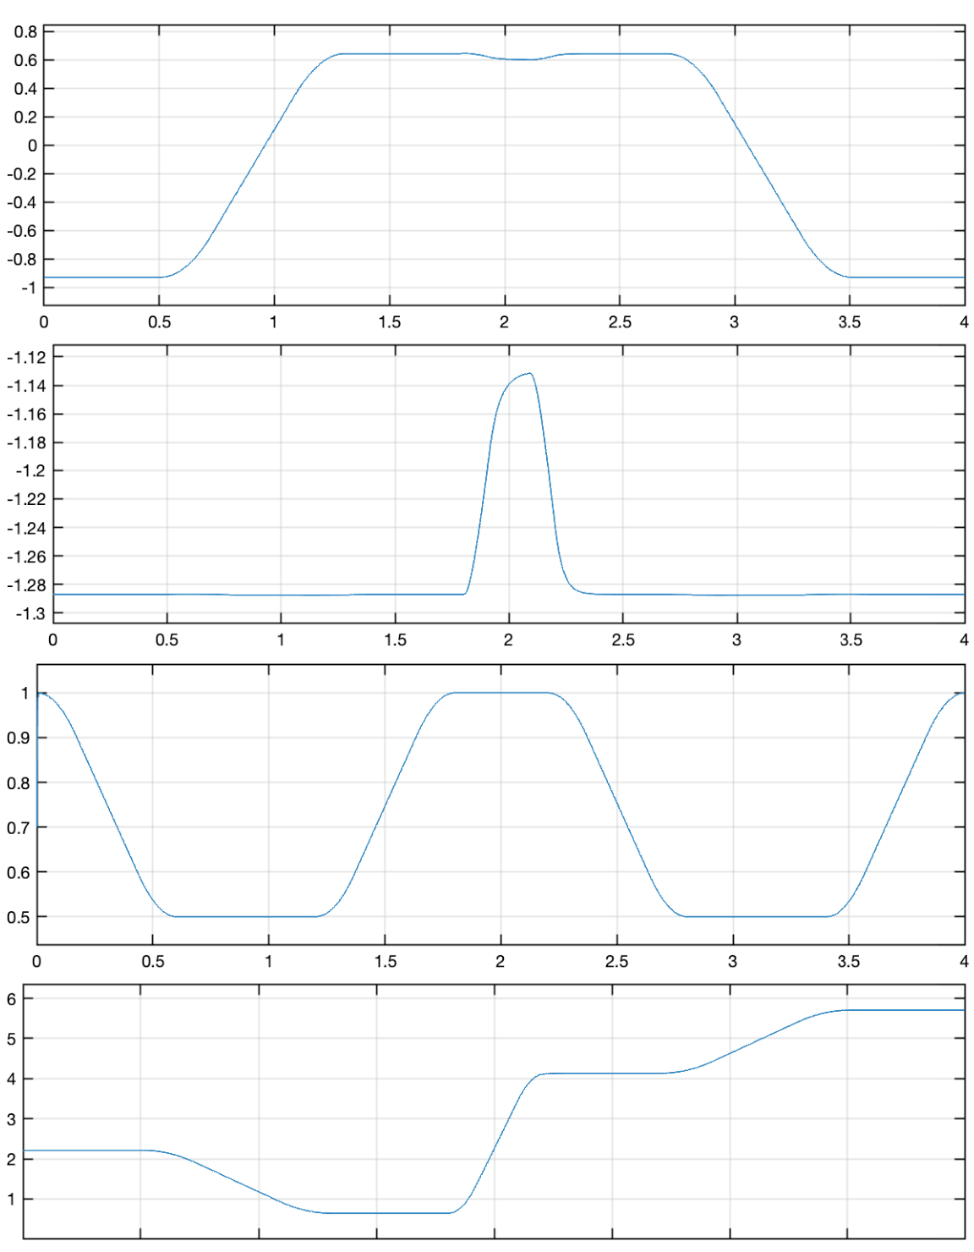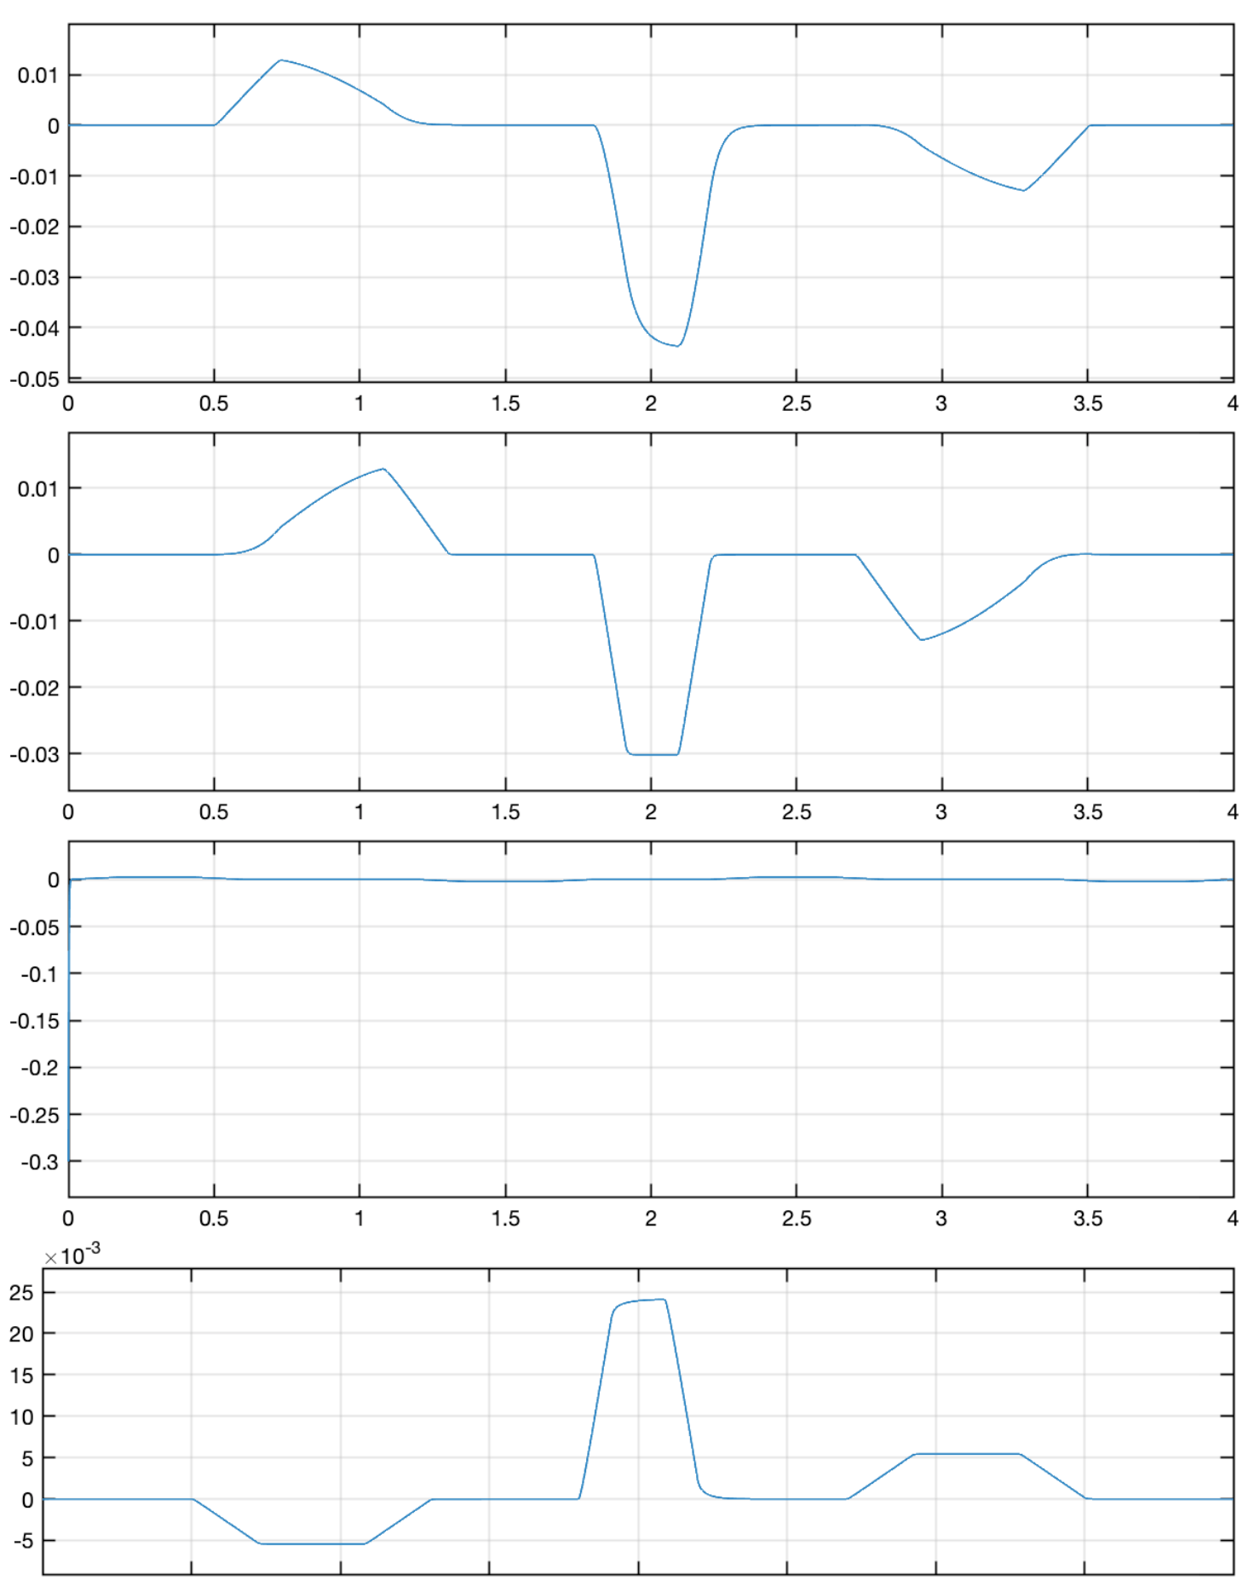

Error Variables plot in the operational space:

$$e_{x}$$

$$e_{y}$$

$$e_{z}$$

$$e_{phi}$$

Part 2

**Relaxing the orientation component**

1. **Explain how you relaxed the phi and how you would write the jacobian pseudo-inverse**

To relax phi, we removed the last row of the Jacobian i.e. the phi component of the Jacobian. This Jacobian matrix contains more columns than rows. Hence it becomes a rectangular matrix. So, we find the pseudo-inverse of rectangular matrix in place of inverse.

Jacobian Pseudo Inverse is written as:

$$J^{†} = J^{T}(J J^{T})^{-1}$$

1. **Write how you choose once relaxed phi to obtain the maximum distance from the end joints**

We choose the relaxed phi in such a way that it is equidistant from the end points i.e. it is in the middle of the joint space of that joint.

In this case the joint space of the last revolute joint ranges from -2 $π$ to 2 $π$. Hence choosing our phi as 0 maximizes the distance from the end joints.

1. **Plot the joint variables and errors in the operational space. Explain the how the constraints are satisfied relaxing that component**

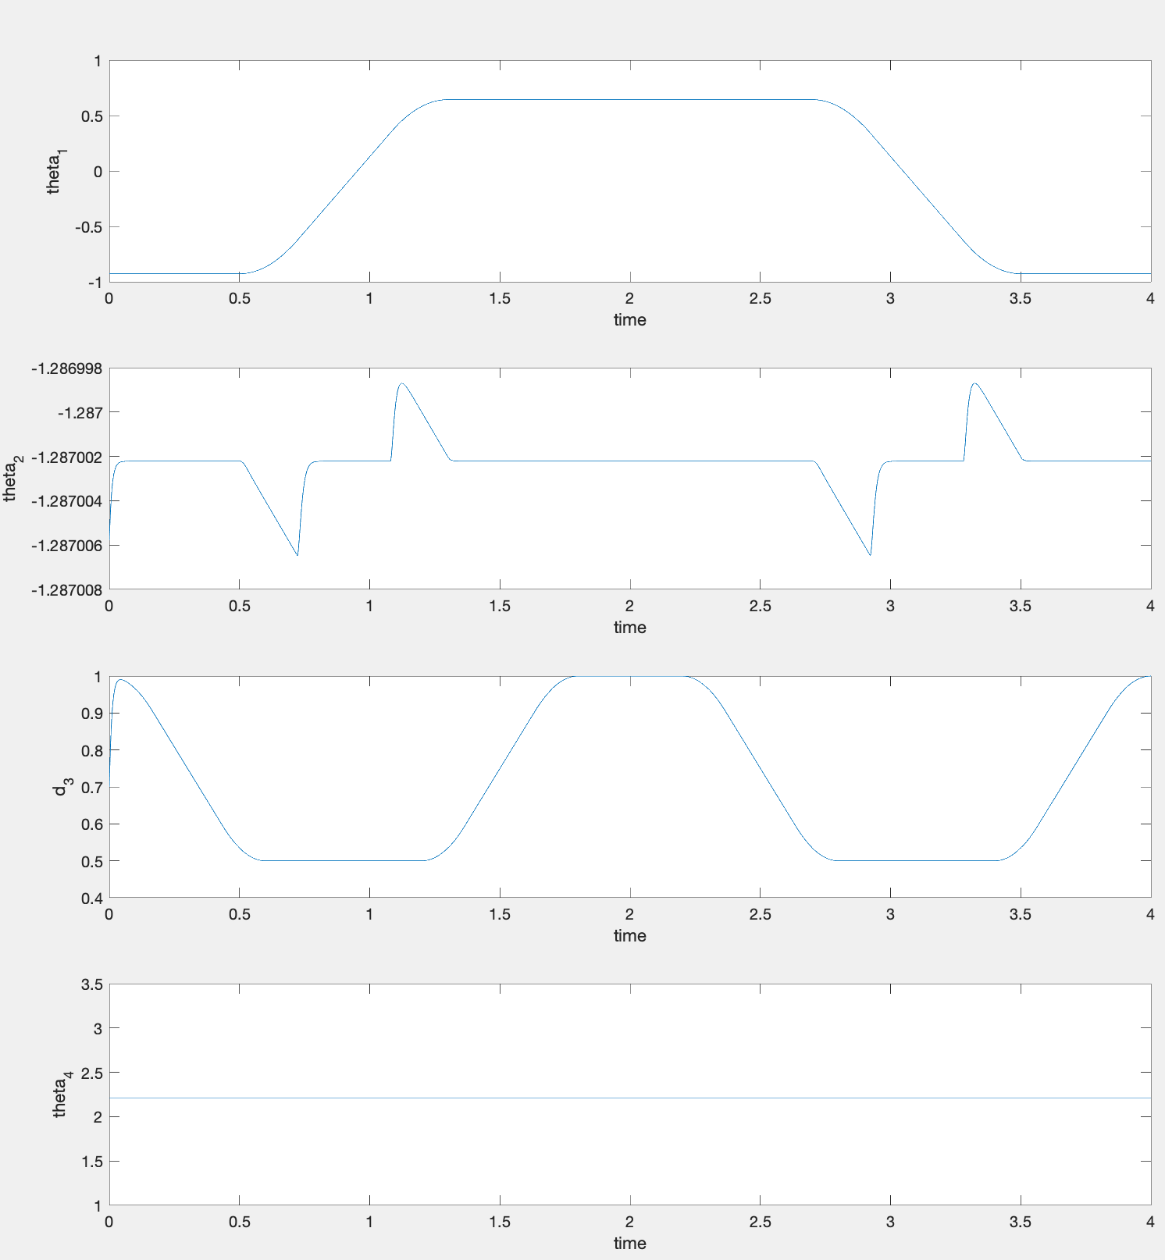

Joint Variables plot in the operational space:

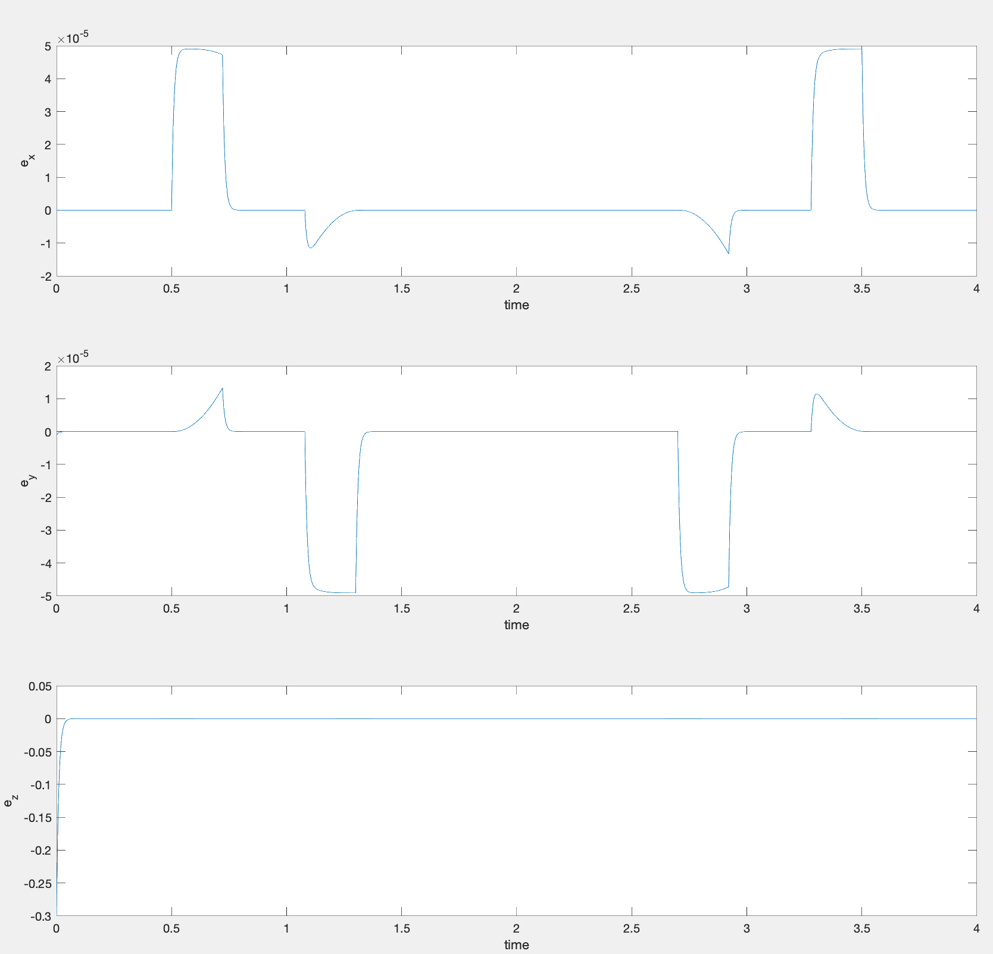

Error Variables plot in the operational space:

**Relaxing the z component**

1. **Explain how you would write the jacobian pseudo-inverse supposing that there is a sphere located at  with radius 0.2 m. Assume you relax the z component in this case.**

When the z component is relaxed, the third row of the jacobian is deleted and hence contains one row less than the total number of columns. Hence it is not possible to find the inverse directly. So, we make use of the pseudo-inverse in place of inverse. Where the pseudo-inverse is given by:

$$J^{†} = J^{T}(J J^{T})^{-1}$$

1. **Write how you choose once relaxed z to obtain the maximum distance from the end joints**

We choose the relaxed z in such a way that it is equidistant from the end points i.e. it is in the middle of the joint space of that joint.

In this case the joint space of the prismatic joint ranges from 0.25m to 1m. Hence, choosing our phi as 0.625m maximizes the distance from the end joints.

1. **Plot the joint variables and errors in the operational space. Explain the how the constraints are satisfied from the plots you have obtained.**

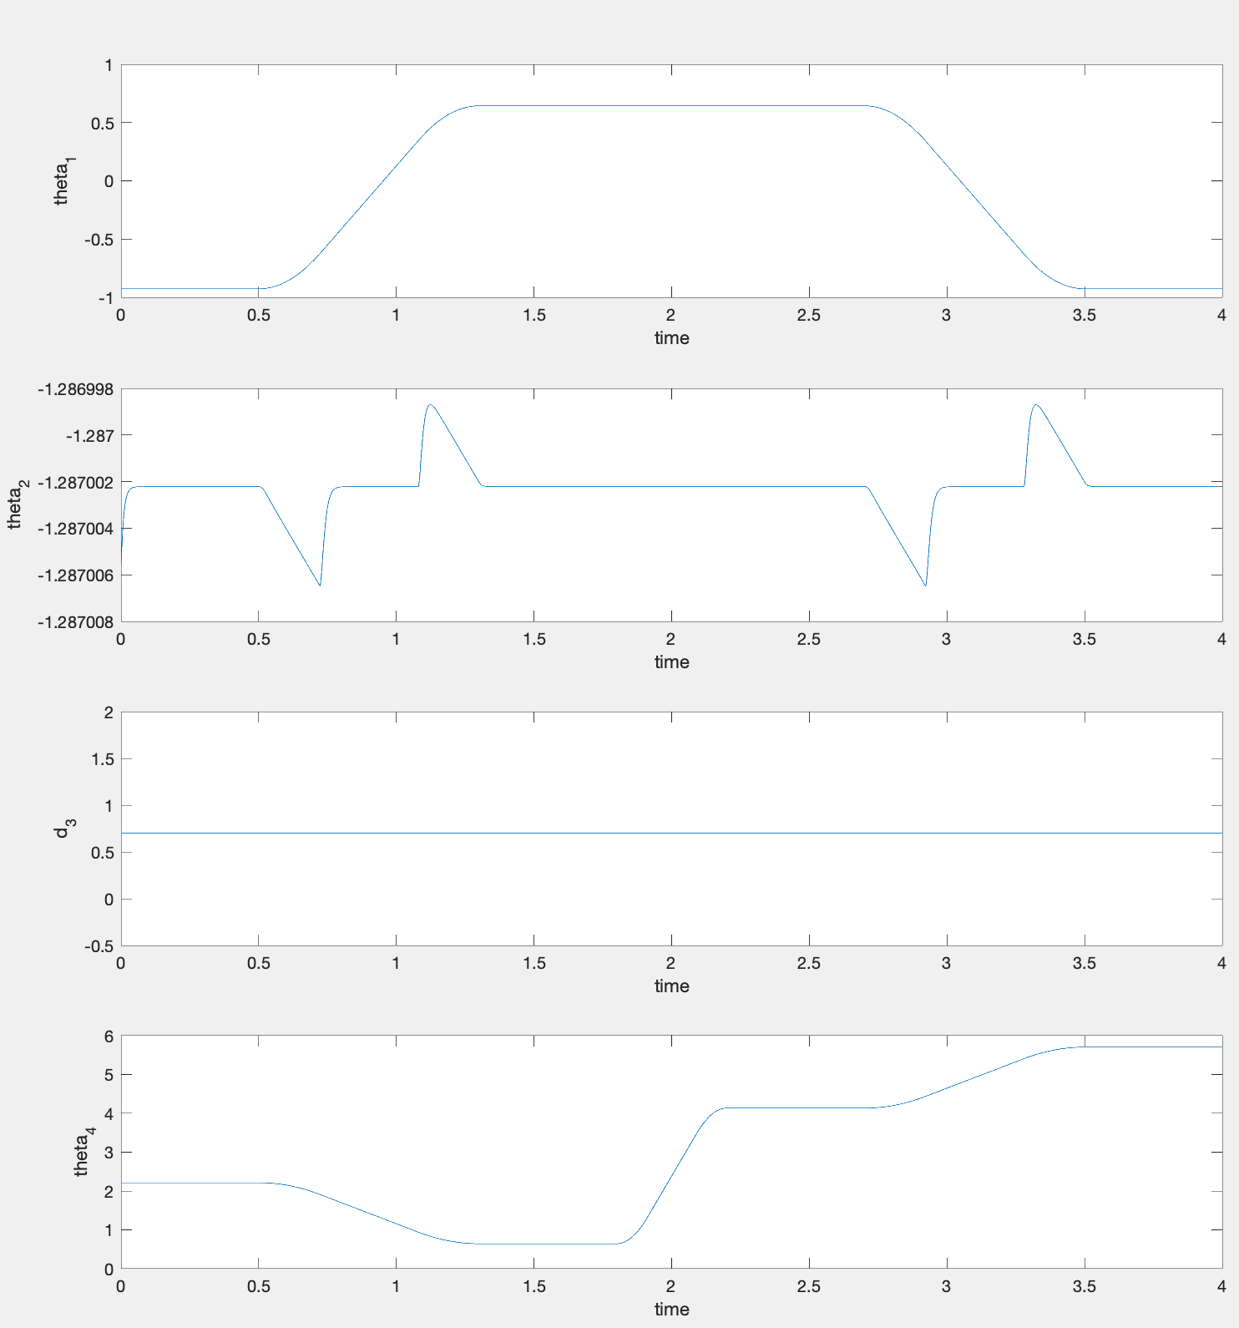

Joint Variables plot in the operational space:

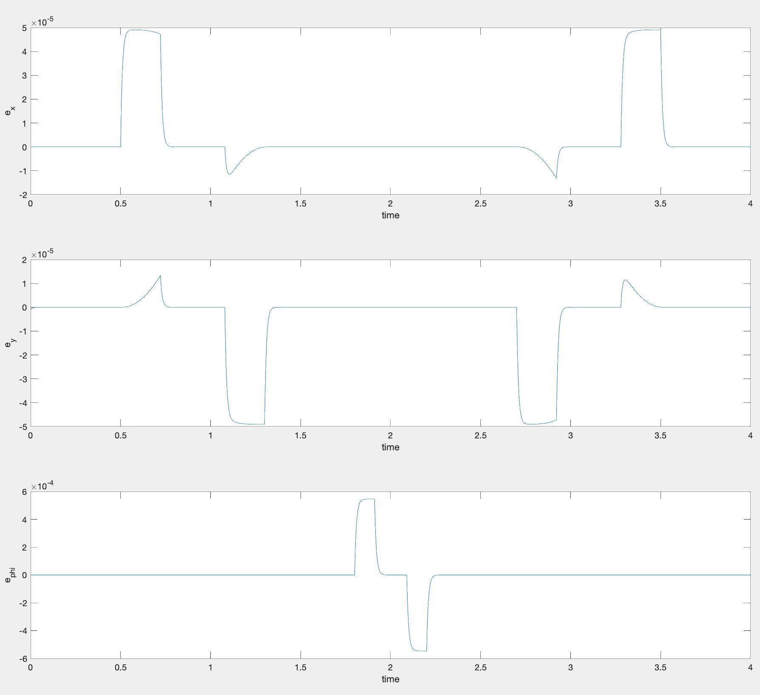

Error Variables plot in the operational space: